

Troop [troop number]
[Leader Information]
[Phone Number]
[Meeting Place]
[Any other misc. information, girls name, etc.]

Benefits of Girl Scouting to Parents

National Girl Scout research has shown that Girl Scouting provides benefits to not only the girls involved, but their parents as well. As a Girl Scout parent you may spend more quality time with your daughter, enjoy a strengthened relationship, build lasting friendships with other adults, and develop leadership skills.

Girl Scouts gives parents and girls the opportunity to be involved in an activity that benefits the community and gives them a sense of personal satisfaction by achieving a goal together.

The Girl Scout Parent’s Promise*

On my honor, I will try:
To encourage and support my Girl Scout daughter,
To help her troop at all times, and
To obey the Girl Scout Parent’s Law

The Girl Scout Parent’s Law*

A Girl Scout Parent understands the true purpose of Girl Scouting.
A Girl Scout Parent gets his/her daughter to and from meetings on time.
A Girl Scout Parent knows a troop is a team effort.
A Girl Scout Parent sees the job through to the end.
A Girl Scout Parent sets a good example at all times.
A Girl Scout Parent is enthusiastic and cheerful.
A Girl Scout Parent does not consider the leader a babysitter.
A Girl Scout Parent brings troop problems to the leader first.
A Girl Scout Parent always does his or her part willingly.
A Girl Scout Parent is aware that Girl Scouting is for all girls.
*GSHNC adapted Parent’s Promise and Law

Responsibility of Girls and Parents

Girl Scout’s Responsibility to the Troop:
- To attend meetings and outings.
- To fulfill obligation of dues, and know that permission slips are signed by a parent or guardian.
- To complete any missed activities.
- To pass along important information to parents or leaders.
- To treat each member of the troop as a sister.
- To respect sister Girl Scouts.
- To respect troop leaders and troop parents.
- To participate in the meetings.
- To conduct themselves in a safe manner.
- To listen to others in the troop and show respect for what they are saying.

Parent’s Responsibility to the Troop:
- To see that your daughter arrives and is picked up on time for all meetings
and outings.
- To help your daughter fulfill troop responsibilities (dues, permission slips, snack, uniforms, etc.).
- To be supportive of your daughter in her Girl Scout endeavors (help her to complete missed activities).
- If possible, to notify the leaders ahead of time if your daughter will not be at a meeting.
- To check with your daughter’s leader for any important news or permission slips that may need to be signed, and to return completed paperwork promptly.
- To assist the troop and the troop leaders during meetings or activities on a rotating or as needed basis.
- To consider being a member of the Troop Committee.
- To keep in contact with the leaders and give them feedback.
- To discuss any issues that arise privately with the leader, not in front of the girls.

Parent’s Responsibility to the Troop (continued):
- To help the troop leaders establish and maintain a positive environment within the troop, by talking with your daughter about acceptable behavior and by setting a positive example yourself.
- To let your daughter know that you consider her participation in Girl Scouting to be important and special.
- To attend parent meetings, group activities and special ceremonies.
- Consider making a personally meaningful, tax-deductible contribution to GSHNC to support the programs and operations of the council and camp properties.

Paperwork

- Parents must complete the following forms:
- Girl Membership Form - annual fee is $15.
- Adult Membership Form - annual fee is $15. Leaders and committee members required, parent volunteers optional.
- Health History Form - this form should be updated every year.
- Activity Permission Slip - no slip, no trip!

Volunteers are the Lifeblood of Girl Scouting

Our volunteers make a difference... in the lives of girls, in the success of families and in the growth of communities. The strength of Girl Scouting rests on the shoulders of adult volunteers who are committed to helping all girls develop into strong, confident, capable women. Remember that your daughter’s troop leader is a volunteer. She spends a great deal of time attending trainings and preparing for and leading her meetings. Please support your Girl Scout’s troop and encourage her participation in activities, to enable her to enjoy her Girl Scout experience. Girl Scouts is a team effort among leaders, girls and parents. There are many ways you can help your Girl Scout’s troop:

- Refreshments manager (bring snacks to each meeting)
- Special events manager (arrange trips and other events)
- Transportation manager (coordinate who will drive on each field trip)
- Recordkeeper (keep all troop records, including registration and individual girl records)
- Recognitions manager (check girls on recognitions work, arrange help when needed, keep recordkeeper informed)
- Phone tree manager (coordinate calling the girls if necessary)
- Fall Sale manager (responsible for the Fall Sales Nuts & Magazines)
- Cookie manager (responsible for the Cookie Sale)
- Emergency contact (available for leaders and parents to contact in case of an emergency while the troop is on a field trip)
- Assistant Leader or Co-Leader

Have you hugged your Troop Leader today?

Your troop leader is a volunteer, paid in smiles and hugs. There are many ways you and your Girl Scout can show your appreciation. Leader Appreciation Day is April 22. Keep in mind that these thoughtful gestures would be greatly appreciated at any time!

- Send a card or letter
- Give her a drawing
- Take a photograph of the troop
- Make a homemade treat
- Offer to babysit for the leader
- Donate to Girl Scouts in her name
- Prepare dinner for the leader and her family
- Thank her in a letter to the editor of your local paper.
- Nominate her for an award (contact service unit for nomination form)

Can one person run a troop?

No! Even with just a few girls, there must be a minimum of two registered adults present, one of whom must be a female.

- Each leader must have a support team of assistant/co-leaders and involved family members.
- When enough people pitch in to help at meetings, the pressure is taken off the leader, and your child receives a better program.

As a parent or guardian, what can I do to help?

- As you enter the meeting, ask what needs to be done. For younger girls, set up projects or snacks, collect dues, take attendance, and hand out materials. With older girls, guide them in these tasks. Take the initiative to guide the girls from activity to activity to avoid chaos
- Take the initiative to help collect and put away materials after a project is completed and help clean up the activity and snack tables. With older girls, help guide the girls to put away and clean up.

Strong volunteer support systems are in place to ensure success

GSHCC has training, manuals, and professional support staff to give volunteers all the tools necessary to be successful. To find out more about upcoming trainings, please visit our website at [insert your council training website link here]

Girl Scout Grade Levels

The Girl Scout age levels are defined by grades. It is important to know your Girl Scout’s grade level so that you can be directed to the appropriate materials and uniforms.

Daisy Girl Scouts - Kindergarten and 1st grade
Brownie Girl Scouts - Grades 2-3
Junior Girl Scouts - Grades 4-5
Cadette - Grades 6-8
Senior - Grades 9-10
Ambassador - Grades 11-12

© 2013 Adapted from Parent Handbook, Girl Scouts, Hornets’ Nest Council, Charlotte, NC

Where to Place Insignia on a Daisy Uniform
A Visual Guide for Awards, Badges, Patches and More



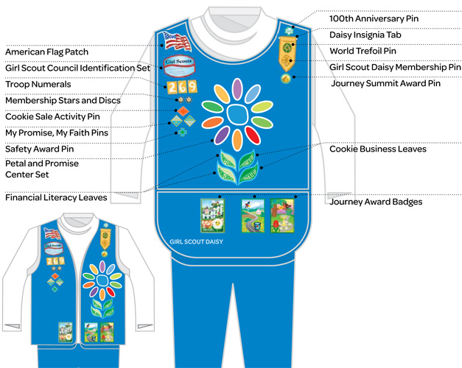

Where to Place Insignia on a Brownie Uniform
A Visual Guide for Awards, Badges, Patches and More

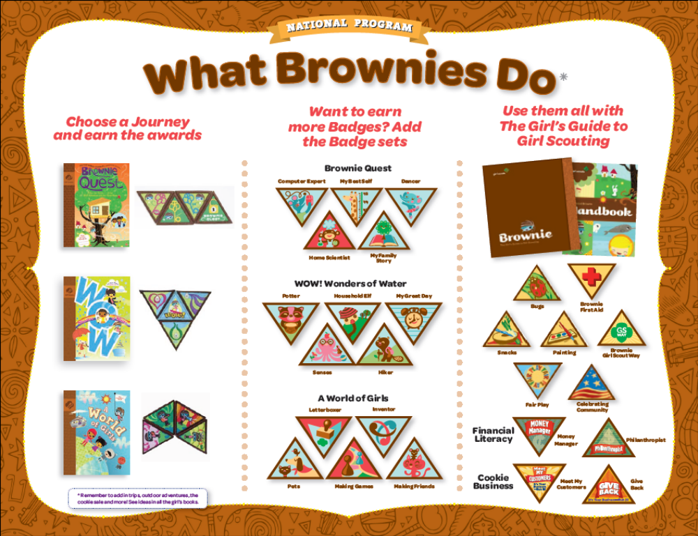

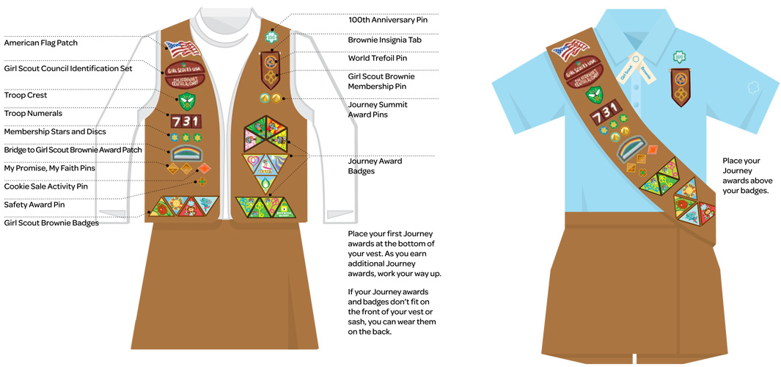

Where to Place Insignia on a Junior Uniform
A Visual Guide for Awards, Badges, Patches and More

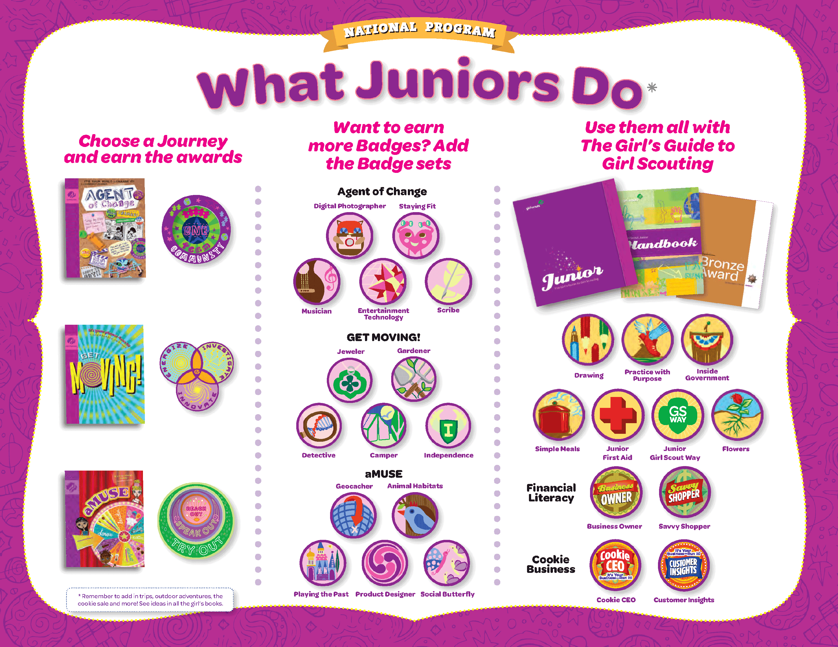

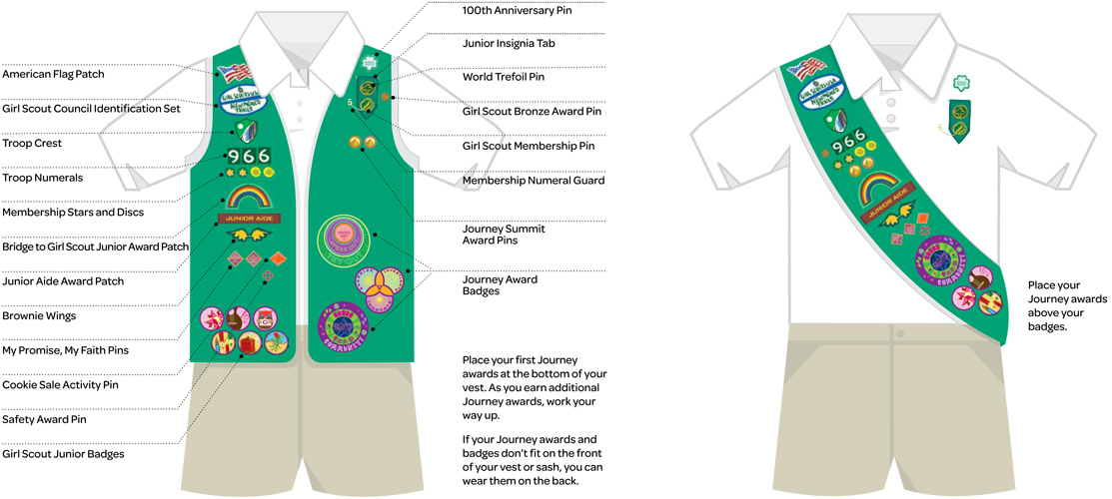
Insignia on a Cadette Uniform
A Visual Guide for Awards, Badges, Patches and More

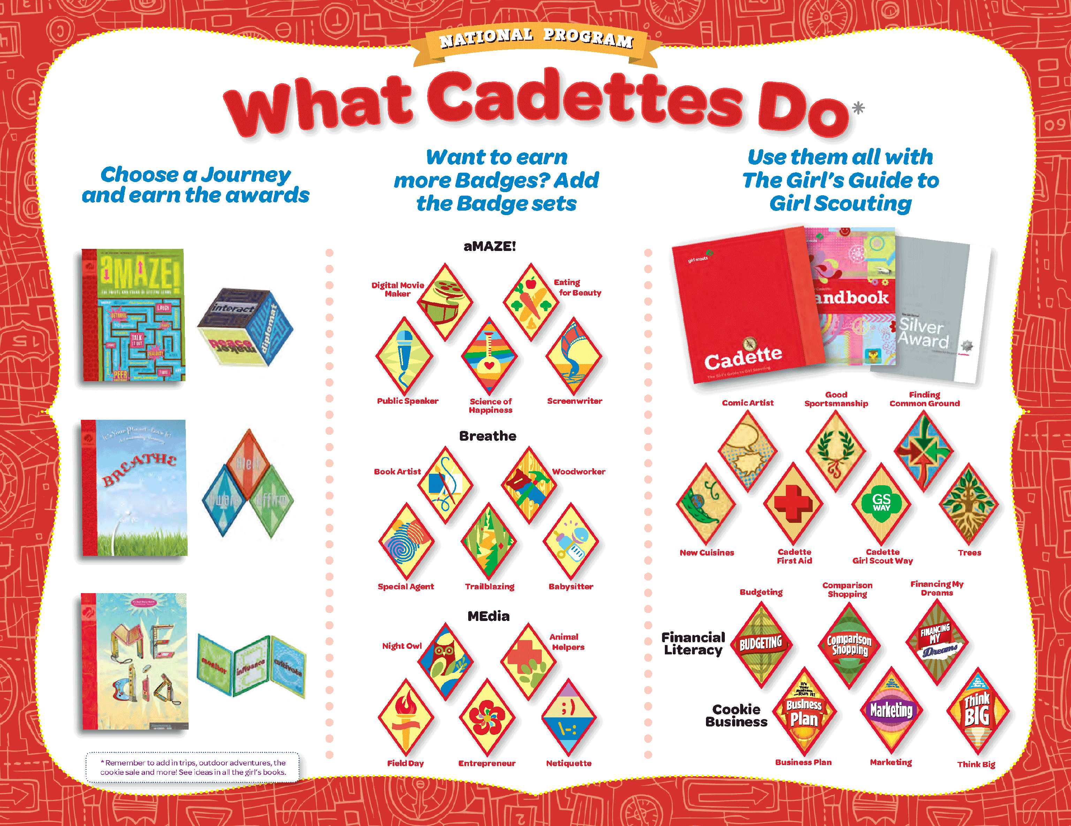

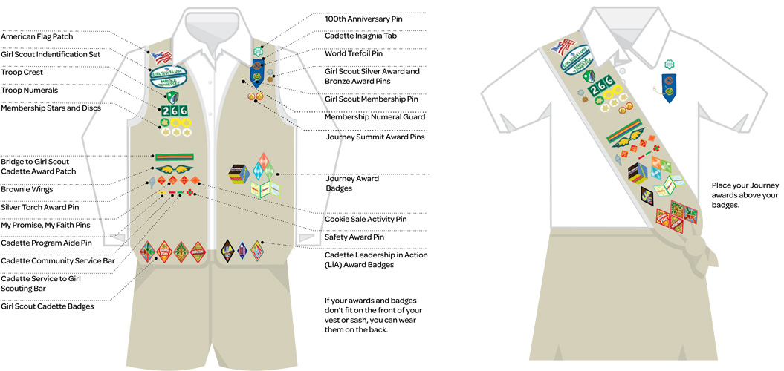

Where to Place Insignia on a Senior Uniform
A Visual Guide for Awards, Badges, Patches and More
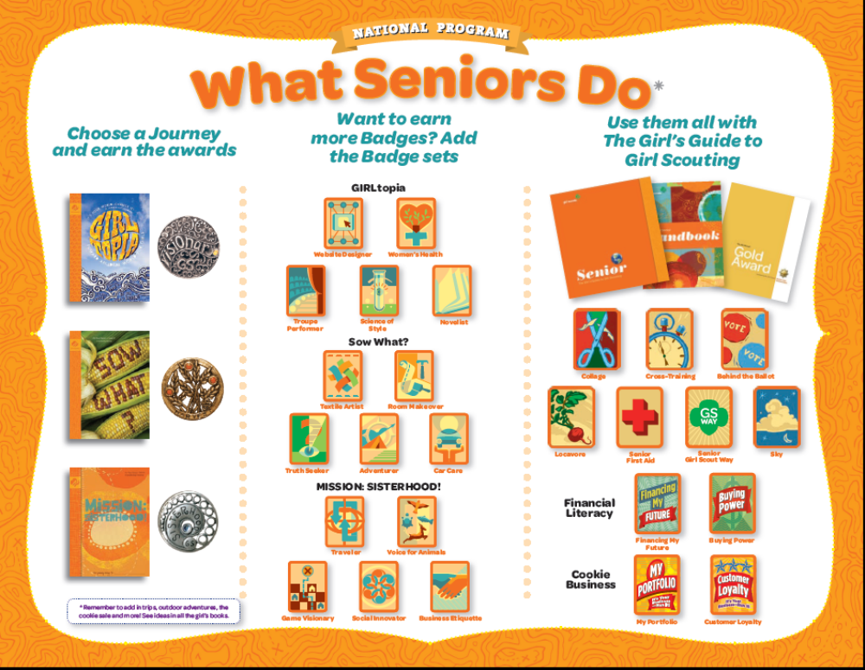

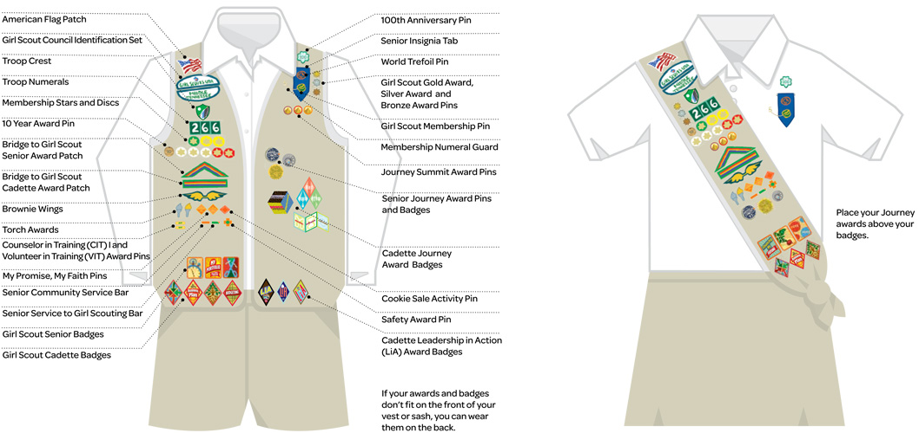

Where to Place Insignia on an Ambassador Uniform
A Visual Guide for Awards, Badges, Patches and More



